# PROJECT PROPOSAL

# Submitted to

# NAANMUDHALVAN NIRAL THIRUVIZHA

# Theme: Solid Waste/ Bio-waste/ E-waste

**Problem Statement No.: 77**

**Problem Statement:**

How might we design a cost-effective, compact, and user-friendly device to help households easily segregate wet and dry waste, improving source segregation, recycling efficiency, and reducing environmental impact at the ward level?

# Mentor Name

# 

# Dr. T. Revathi, HoD/IT

# Team Members

# 

# Vijesh Pethuram K (9517202106056)

# Kanishkaran K (9517202106021)

# Raj Karna G (9517202106252)

# PROJECT PROPOSAL

1. **Theme**: Solid Waste/ Bio-waste/ E-waste
2. **Problem statement**: How might we design a cost-effective, compact, and user-friendly device to help households easily segregate wet and dry waste, improving source segregation, recycling efficiency, and reducing environmental impact at the ward level?
3. **College Code & College Name**: 9517 - Mepco Schlenk Engineering College, Sivakasi.
4. **Guide Name, Designation, Mobile No. & Email id**: Dr. T. Revathi, HoD/IT, 9442325608, trevathi@mepcoeng.ac.in.
5. **Student Team details**:

|  |  |  |  |  |  |
| --- | --- | --- | --- | --- | --- |
| Sl.No. | Student Reg.  No. | Name of the  Student | Branch | Mobile No. | email id |
|  | 9517202106056 | Vijesh Pethuram K | Information Technology | 8637480351 | vijesh.moses@gmail.com |
|  | 9517202106021 | Kanishkaran K | Information Technology | 8489834410 | kalidassumithra425@gmail.com |
|  | 9517202106252 | Raj Karna G | Information Technology | 9075950243 | rajkarna65@gmail.com |

1. **Project Summary**:

Our project aims to develop an automated waste segregation system leveraging machine learning and accessible hardware to effectively sort waste into Wet waste and Dry waste categories. Addressing the inefficiencies of manual waste sorting, particularly in households and small businesses, this project utilizes TinyML technology on a compact setup. The system features a microcontroller-based TinyML model that classifies waste through real-time image analysis, along with a DC motor-driven conveyor belt and an IR sensor to detect incoming waste. An automated sorting mechanism, controlled by a stepper motor, directs the classified waste into appropriate compartments, enhancing efficiency while promoting environmental sustainability. By reducing manual effort and providing an affordable solution for effective waste management, the project seeks to make responsible waste disposal practices more accessible.

1. **Proposed solution with methodology**:

**Hardware Diagram:**



Conveyor belt motor

Stepper Motor

Camera Module

Motor Driver

IR Sensor

TinyML Board

**Waste Classification Flow:**

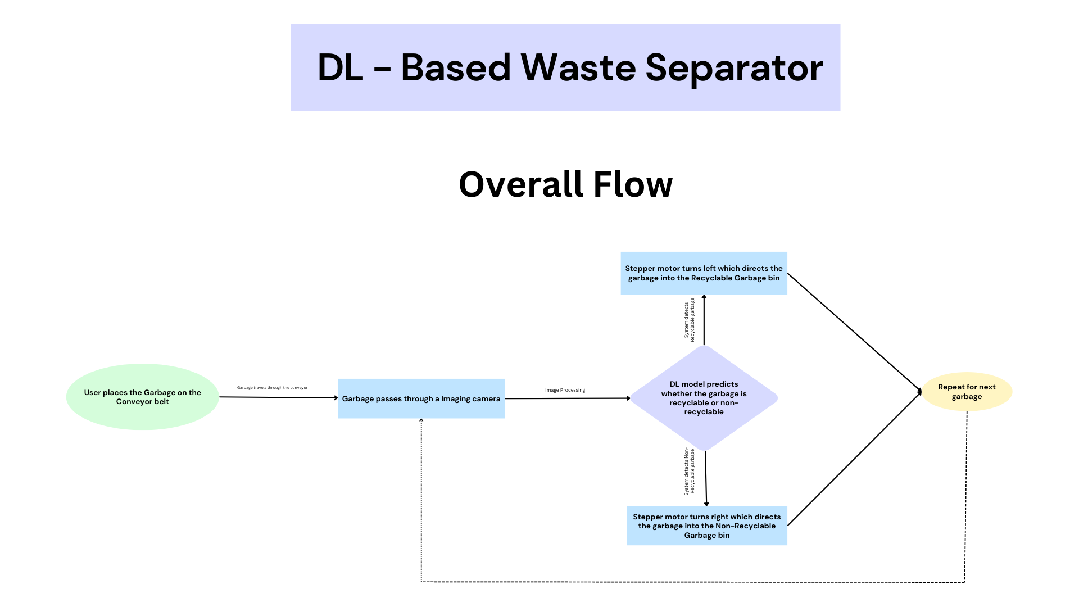

**Waste Classification Processes:**

1. **Object Detection:**

The process begins when waste is placed on the conveyor belt. An IR sensor detects the presence of the waste item as it moves along the conveyor.

1. **Image Capture:**

Once the IR sensor detects the item, it triggers the system to capture an image of the waste using a camera module integrated with the microcontroller.

1. **Image Processing:**

The captured image is then sent to the TinyML model, which processes the image to classify the waste item. This model has been trained to identify whether the item is Wet waste or Dry waste based on its visual features.

1. **Classification Decision:**

The TinyML model analyzes the image and produces a classification result indicating the type of waste—either Wet waste or Dry waste.

1. **Sorting Mechanism Activation:**

Based on the classification result, the system activates the stepper motor to rotate the sorting bin to the appropriate position. If the item is classified as Wet waste, the rotation will direct the waste to the Wet waste compartment; if classified as Dry waste, it will go to the Dry waste compartment.

1. **Waste Dispersion:**

The waste is then dropped into the respective bin, ensuring that Wet waste and Dry waste materials are separated correctly, thus preventing cross-contamination.

1. **Workplan / time schedule indicating the project mile stones**:

|  |  |  |
| --- | --- | --- |
| Milestone | Description | Duration |
| 1. Project Initiation | Form project team, define objectives and scope, initial planning. | 1 week |
| 2. System Design | Design the hardware setup and software architecture. | 1 week |
| 3. Hardware Development | Assemble the components and set up the hardware for the waste segregation system. | 2 weeks |
| 4. Machine Learning Model Development | Collect and preprocess the dataset; train the TinyML model for waste classification. | 1 week |
| 5. System Integration | Integrate hardware and software components; implement communication between the components. | 1 week |
| 6. Testing and Validation | Conduct tests on the integrated system to assess classification accuracy and sorting efficiency; make necessary adjustments. | 3 days |

1. **Plan of action of implementation**:
2. **System Design:**

* Design the overall system architecture, including hardware components (conveyor belt, IR sensor, camera, stepper motor) and software architecture for the TinyML model.
* Develop detailed schematics for the electronic components and layout for the physical assembly.
* Plan the integration process for hardware and software systems.

1. **Hardware Development and Assembly:**

* Assemble the hardware components according to the designed schematics.
* Perform initial tests to ensure all parts are functional (e.g., check motor operation, sensor detection capabilities).
* Integrate the camera module with the microcontroller.

1. **Machine Learning Development:**

* Collect and preprocess a dataset of waste images for training the TinyML model.
* Develop, train, and test the machine learning model to ensure accurate classification of wet and dry waste.
* Optimize the model for real-time processing on the microcontroller.

1. **System Integration:**

* Integrate the TinyML model with the hardware components, ensuring smooth communication between sensors, camera, and the microcontroller.
* Develop the control logic that manages the flow from detection to classification and sorting.

1. **List of facilities available in the college to develop the prototype of the project**:
2. Network Facility
3. Embedded Systems Laboratory
4. Garage Facility
5. Access to software tools for circuit simulation (e.g., Proteus)
6. **Nature of Industry support for the project**:

* Embedded Systems Technical Expertise
* Image Processing Industries
* Promoting Sustainability Initiatives
* Waste Handling Companies

1. **Total Cost**: Rs. 8000 /-
2. **Details of Financial assistance required**:

* Arduino Nano BLE sense (TinyML Kit with camera module) – Rs. 7000 /-
* IR sensor – Rs. 100 /-
* Stepper Motor with driver – Rs. 250 /-
* Conveyor belt motor (Gear) – Rs. 150 /-
* Bread board – Rs. 250 /-
* Jumper Wires – Rs. 50 /-
* Cardboard for the Conveyor Platform – Rs. 200 /-

1. **Expected outcomes / results**:

* An automated waste segregation system that accurately classifies waste into Wet waste and Dry waste categories by image classification using machine learning algorithms.
* Then Automatically, the waste is dropped into the appropriate bin by using the conveyor belt.

# UNDERTAKING

1. ALL the students are studying in final year engineering. All the students are registered only once for this scheme.
2. The college will provide the basic infrastructure and other required facilities to the students for timely completion of their projects.
3. The college assumes to undertake the financial and other management responsibilities of the project. We are aware that the amount is to be utilized only for the purpose sanctioned i.e. to meet the expenses for developing the prototype and not for purchase of computer consumables, stationaries, honorarium, overhead etc. Unutilised balance amount will be returned back to the University after the time of completion of the project.

|  |  |  |
| --- | --- | --- |
| Name and Sign of  Student 1 | Name and Sign of  Student 2 | Name and Sign of  Student 3 |

Signature of the Mentor Signature and seal of the Principal